**Weekly Status Report - 2018-MAY-28**

|  |  |
| --- | --- |
| **Project Name** | MLIK |
| **Team Lead** | Isaac Thiessen |

|  |  |  |  |  |
| --- | --- | --- | --- | --- |
| **Roles** |  |  |  |  |
| **Week** | **Ashleigh Logan** | **Brendon Waters** | **Isaac Thiessen** | **Jacob Warnes** |
| 01 | Team Lead, Technical Writer, Database/Back-End | Front-End Developer, Technical Writer, Database/Back-End Developer | Technical Writer, Database/Back-End Developer | Technical Writer, Database/Back-End Developer |
| 02 | Front End Developer, Technical Writer | Team Lead, Technical Writer | Backend – Database, Technical Writer | Middleware – PHP, Technical Writer |
| 03 | Front-End/Middleware | Technical Writing | Middleware - PHP, Team Lead | Middleware |
| 04 |  |  |  |  |
| 05 |  |  |  |  |
| 06 |  |  |  |  |
| 07 |  |  |  |  |
| 08 |  |  |  |  |

|  |
| --- |
| **Weekly Project Summary** |
| Weekly Status Report for week 2 completed. Product page compete, product entry form complete. Database has been populated with data, some sample data, some will be there to stay. |

|  |  |  |  |  |  |
| --- | --- | --- | --- | --- | --- |
| **Key Milestones Status** | | | | | |
| **ID** | **Description** | **Planned Completion** | **Forecasted**  **Completion** | **Actual Completion** | **Status** |
|  | Demo and Deliverables Week 1 Completed | *2018-05-15* | *2018-05-15* | *2018-05-15* | *Complete* |
|  | Demo and Deliverables Week 2 Completed | 2018-05-22 | 2018-05-22 | 2018-05-22 | Complete |
|  | Demo and Deliverables Week 3 Completed | 2018-05-29 | 2018-05-29 | 2018-05-29 | Complete |
|  | Demo and Deliverables Week 4 Completed | 2018-06-05 | 2018-06-05 |  | Incomplete |
|  | Demo and Deliverables Week 5 Completed | 2018-06-11 | 2018-06-11 |  | Incomplete |
|  | Demo and Deliverables Week 6 Completed | 2018-06-18 | 2018-06-18 |  | Incomplete |
|  | Demo and Deliverables Week 7 Completed | 2018-06-22 | 2018-06-22 |  | Incomplete |
|  | Final Presentation | 2018-06-22 | 2018-06-22 |  | Incomplete |
|  | Final Report | 2018-06-22 | 2018-06-22 |  | Incomplete |

|  |
| --- |
| **Key Accomplishments for the Week** |
| * Week 2 Status Complete * Database populated with meaningful data ( Products, Categories, Customers ) * Add products form complete * Product page completed * Customer can restrict items they see on the product page by category |

|  |  |  |  |
| --- | --- | --- | --- |
| **Task Assignments for the Coming Week** | | |  |
| **ID** | **Description** | **Assigned To** | **On Schedule** |
| 51 | Login Page | Ashleigh | *Yes* |
| 52 | Order Placement page | Isaac | Yes |
| 53 | Product Page | Brendon | Yes |
| 54 | Shopping Cart | Jacob | Yes |

|  |  |  |
| --- | --- | --- |
| **Tasks Completed in the Previous Week** | |  |
| **ID** | **Description** | **Assigned To** |
| 41 | Complete Webpage Alpha | Brendon, Ashleigh |
| 46 | Complete Task Log | Brendon |
| 47 | Update Weekly Status Report | Isaac |
| 42 | Git Repository Report | Jacob |
| 39 | Schedule Demo | Brendon |

|  |  |
| --- | --- |
| Issues and Risks |  |
| **Description** | **Impact**  **(L,M,H)** |
| Short amount of time to complete project | M |
| Lost working hours due to holiday Monday putting us slightly behind schedule | M |

|  |
| --- |
| **Gantt Chart** |

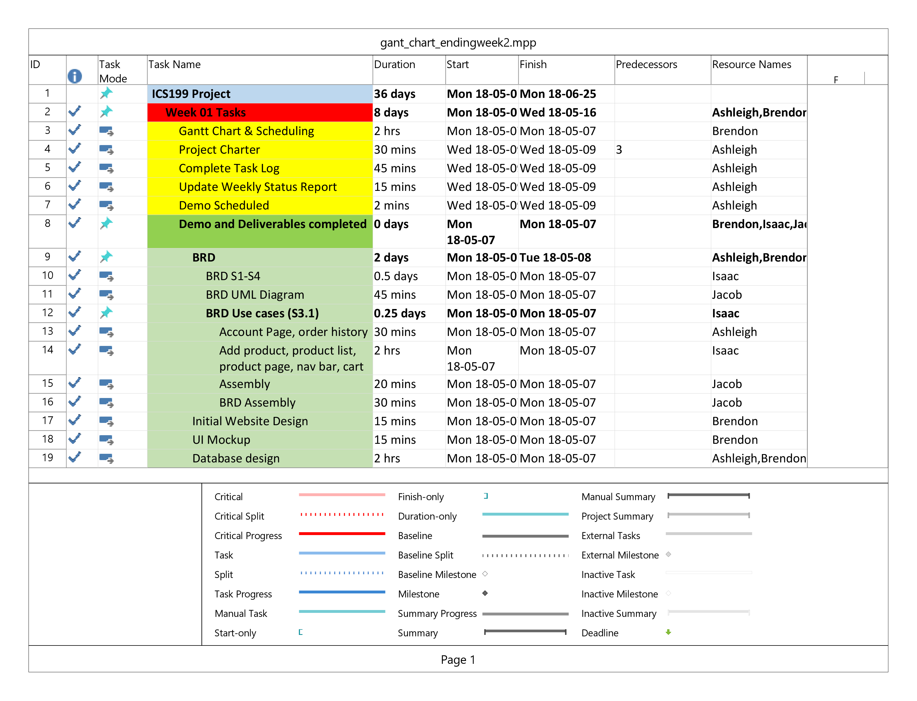

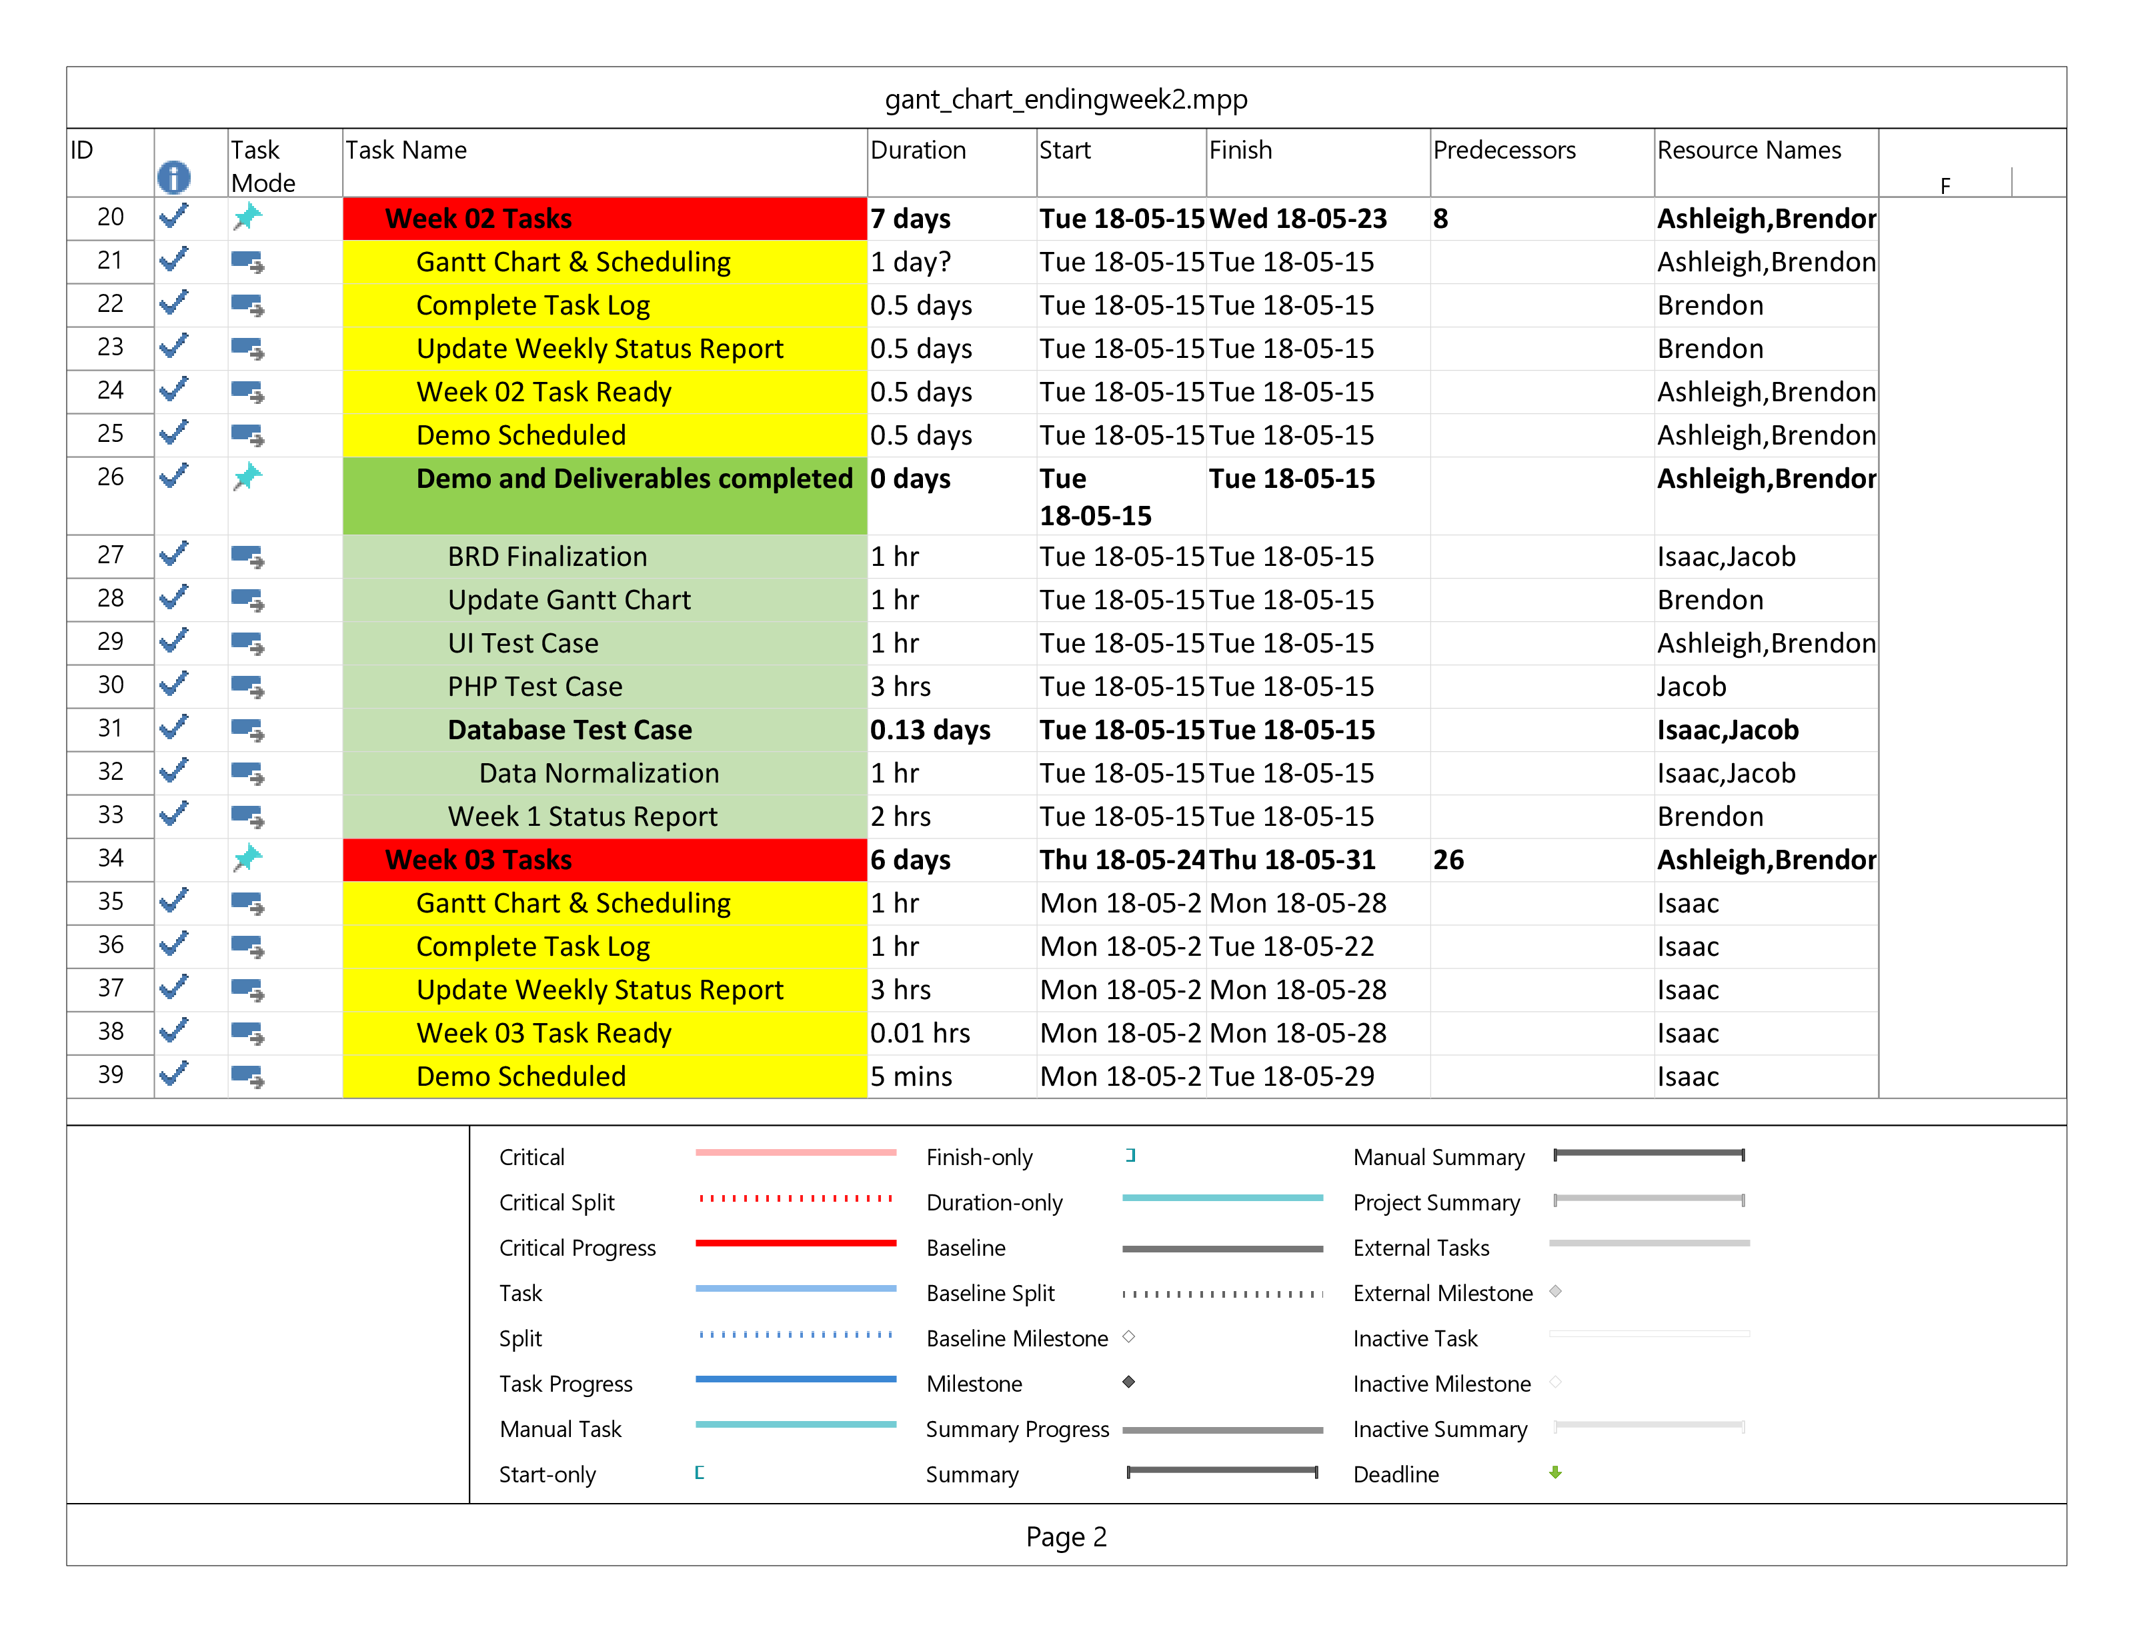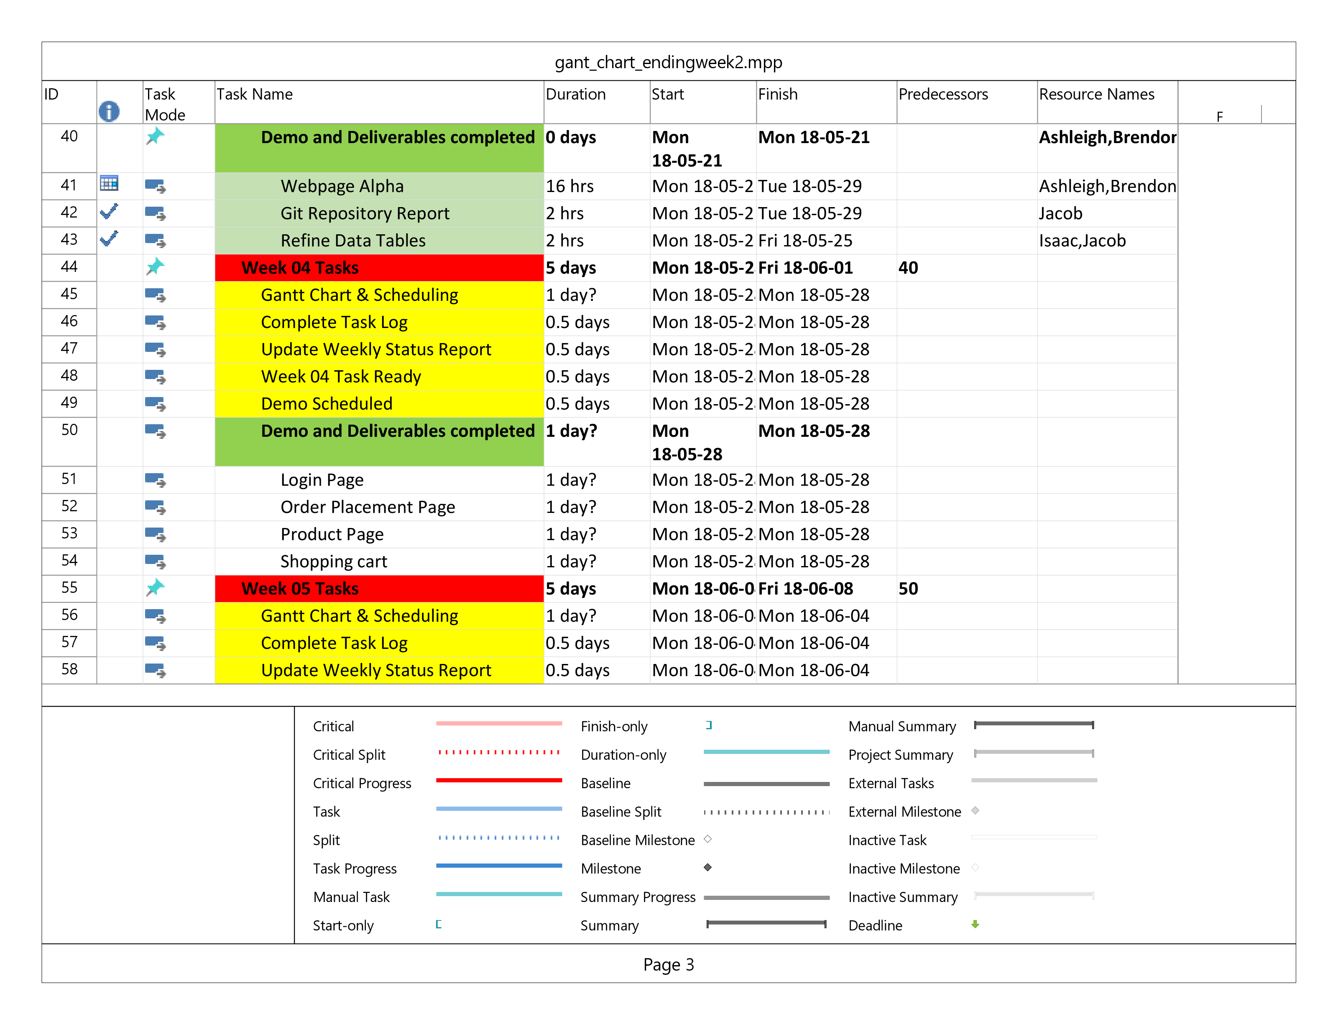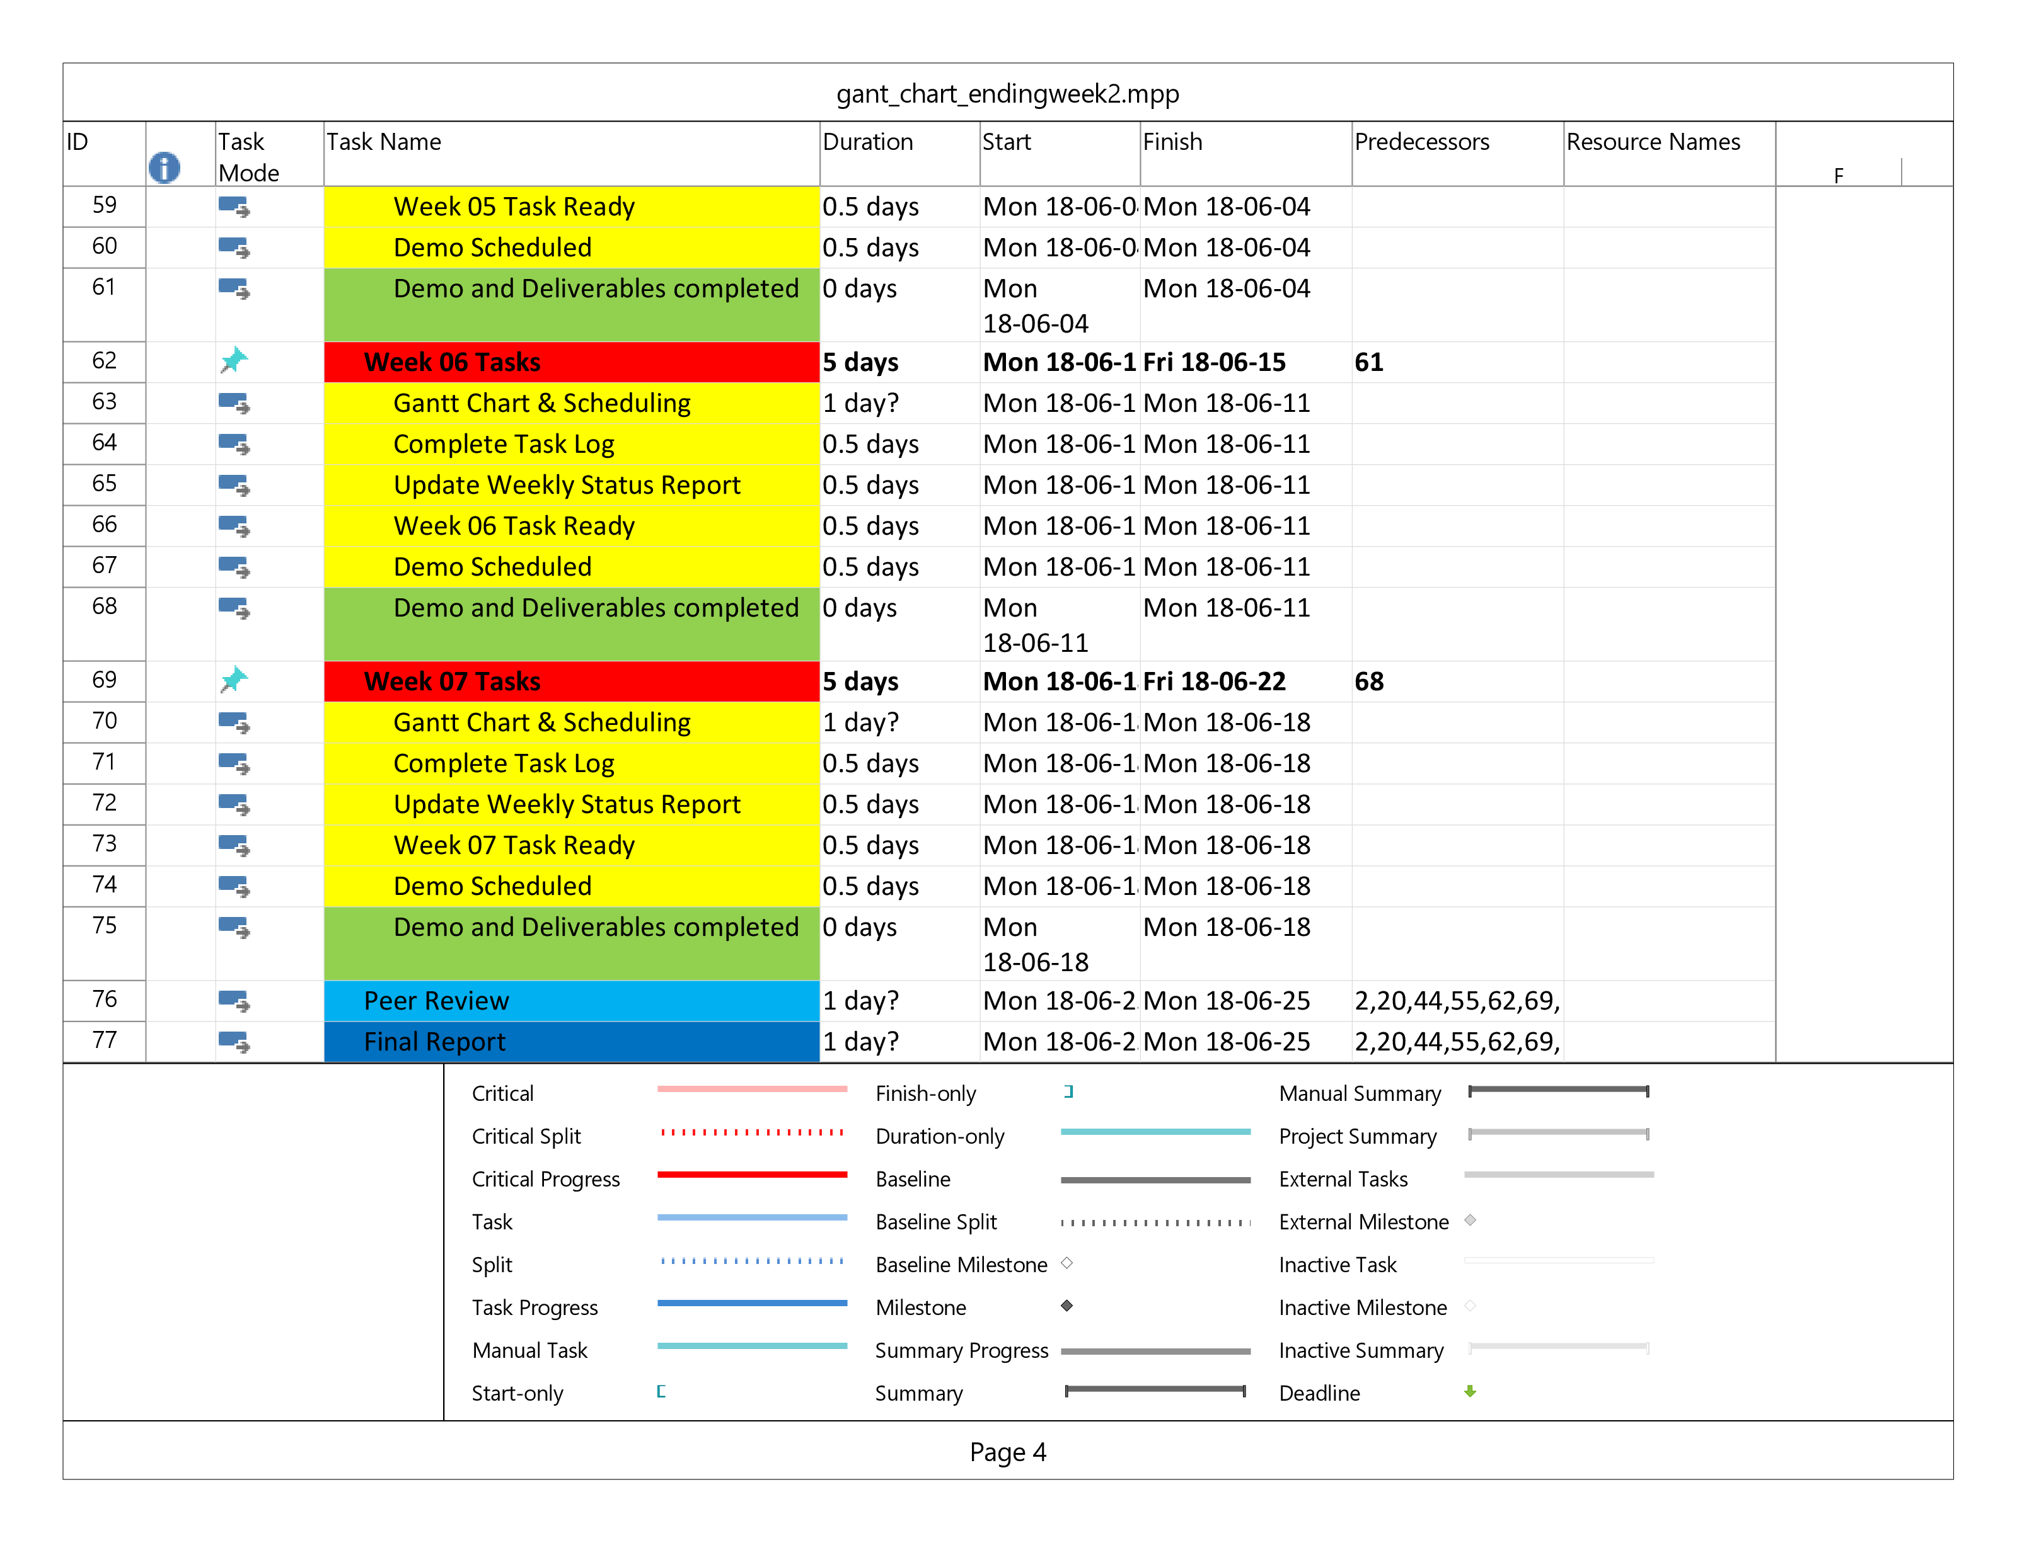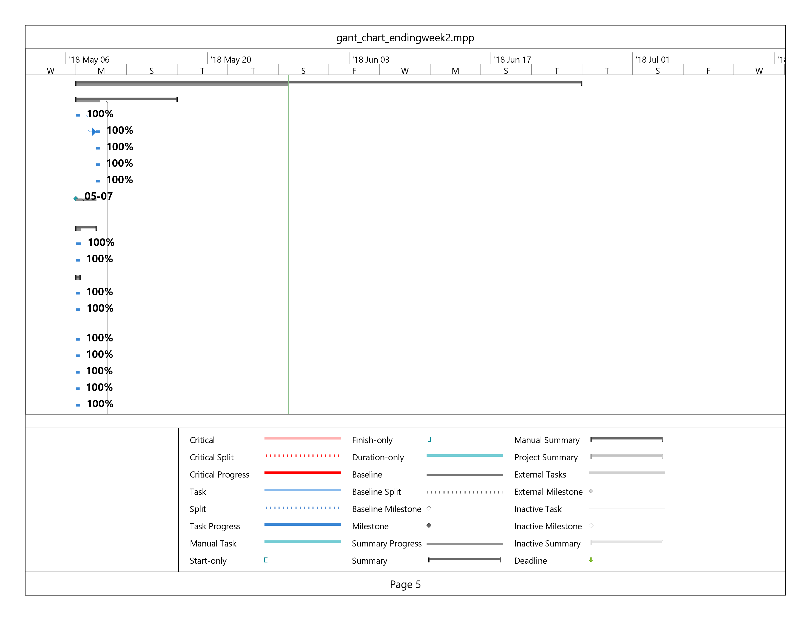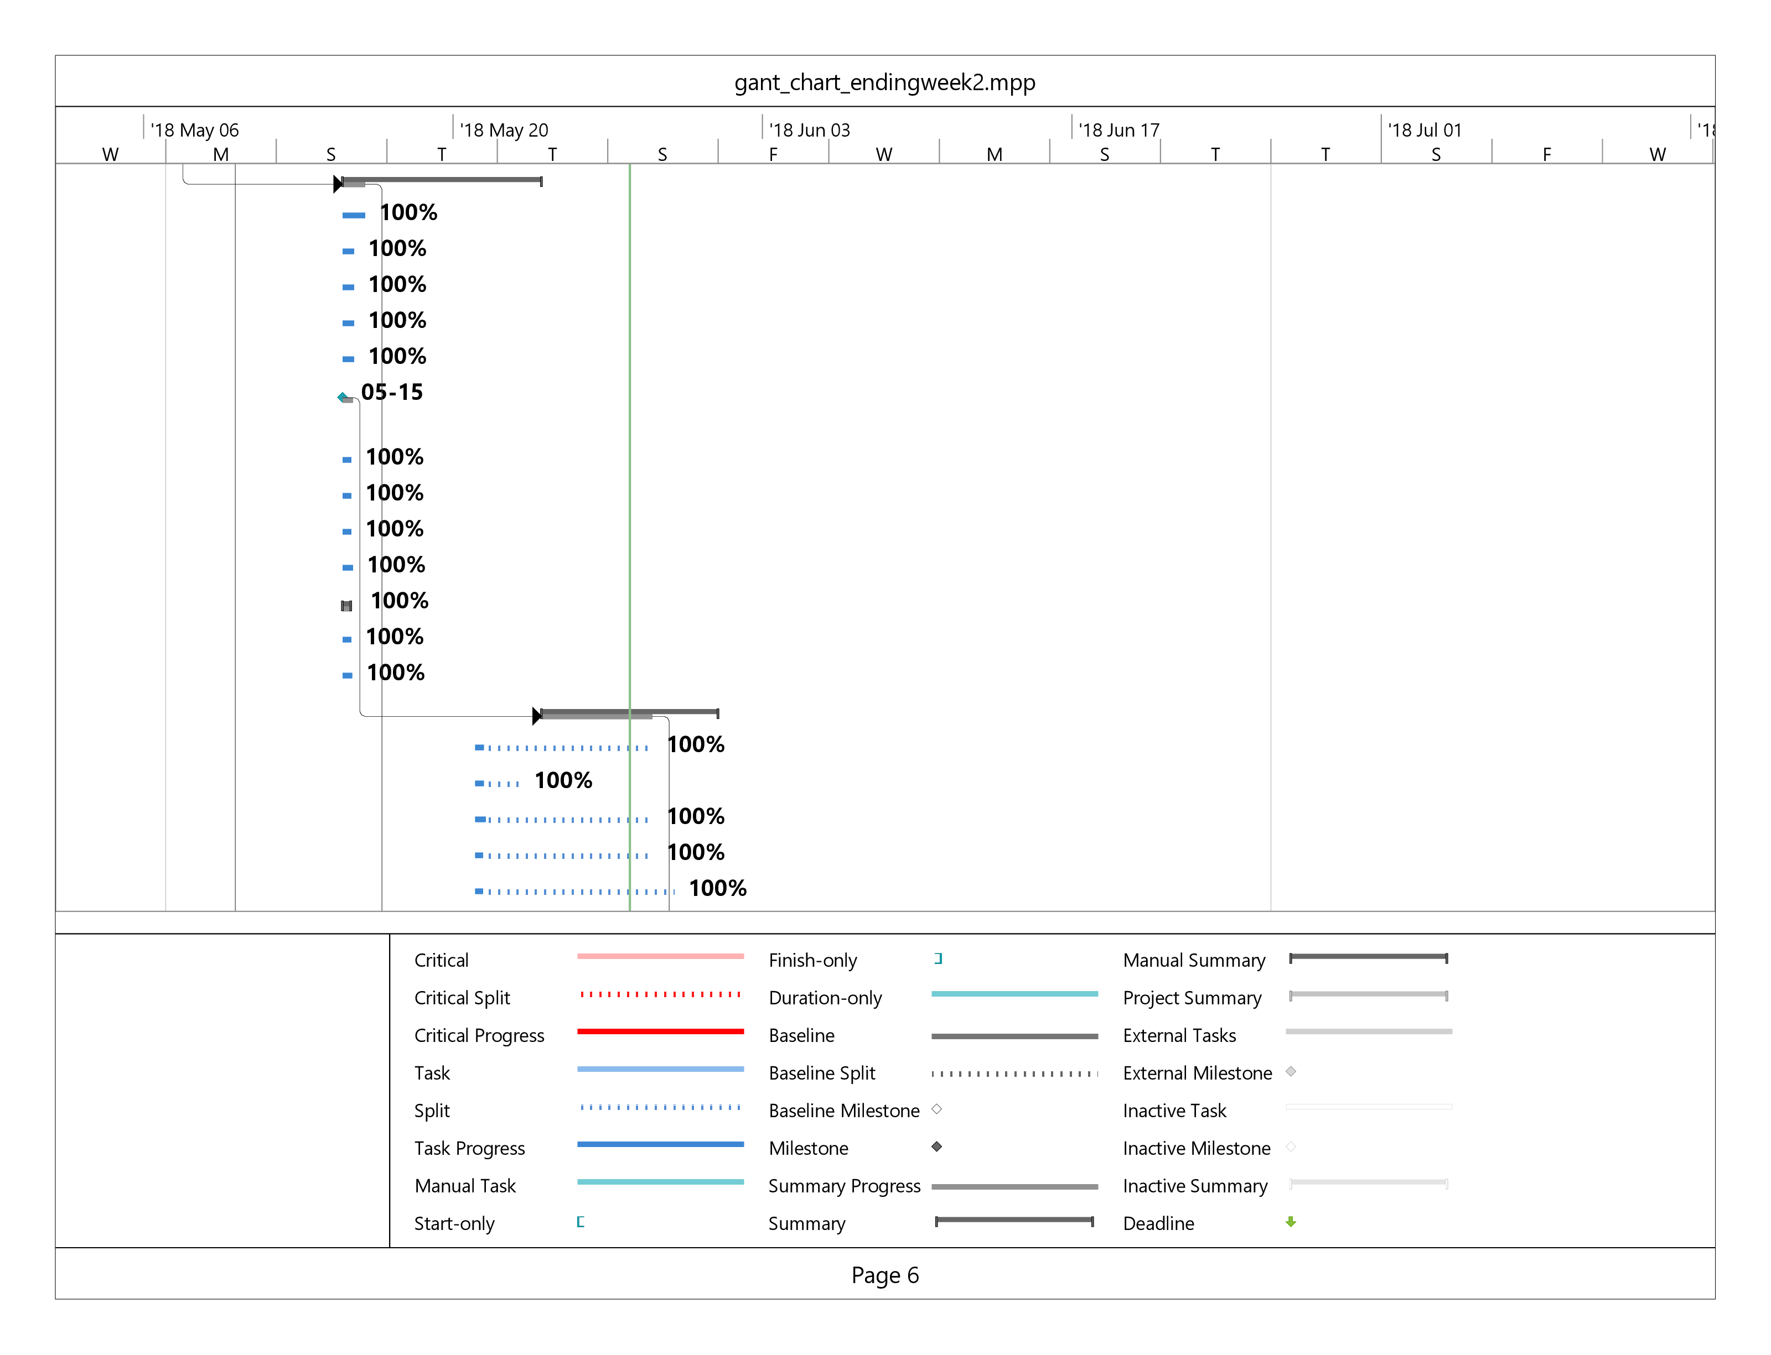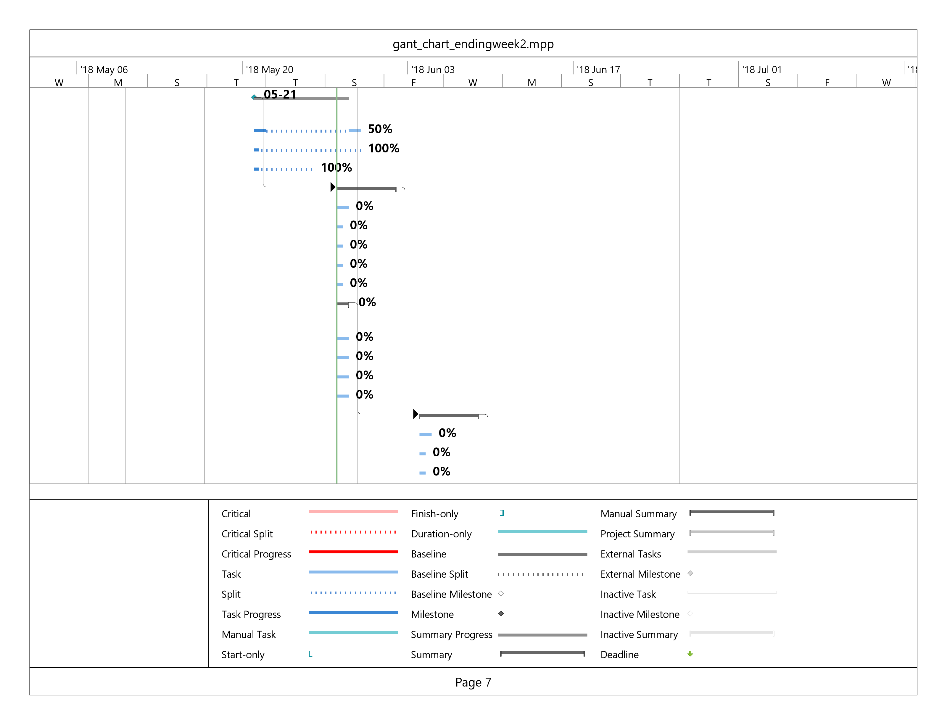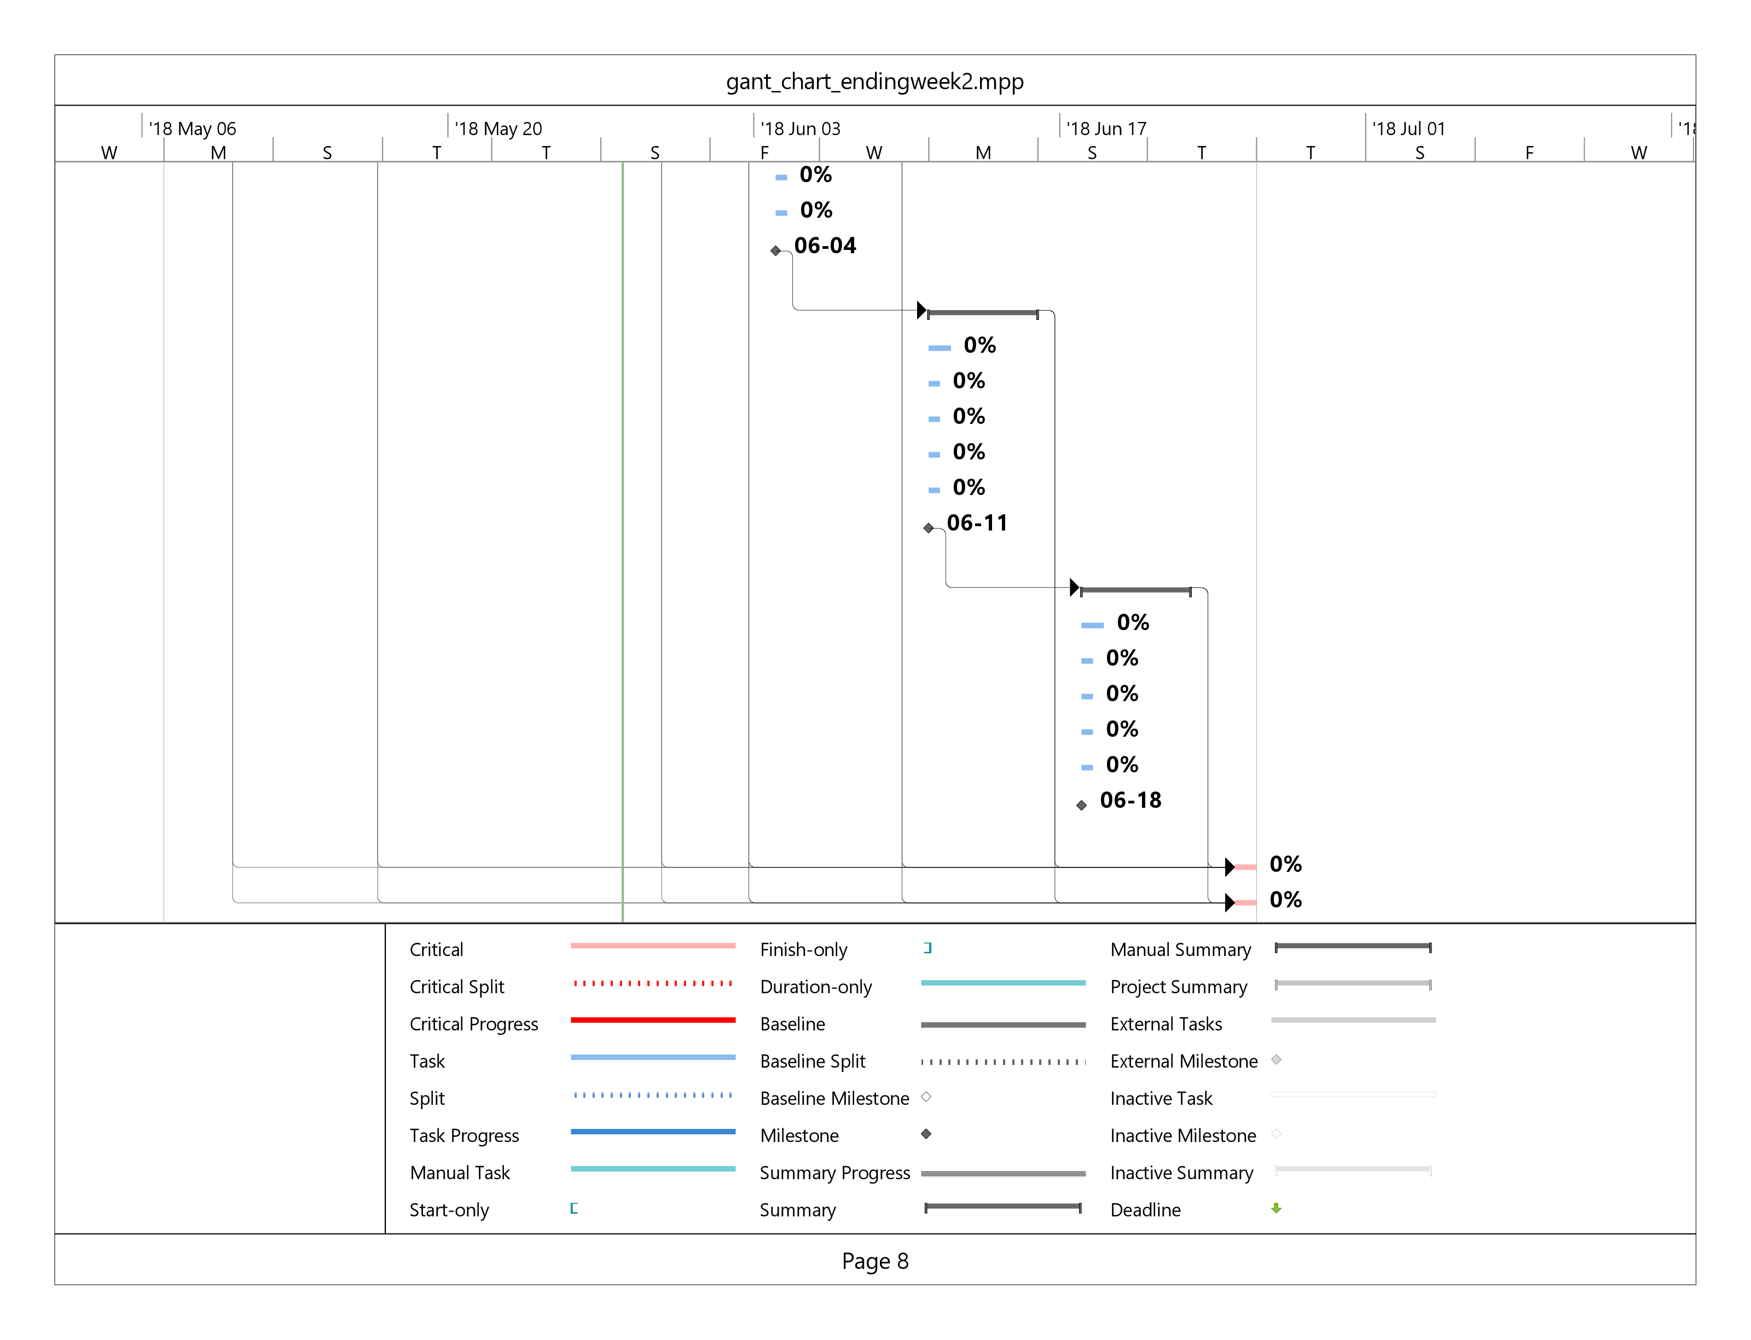

|  |
| --- |
| **Git Repository Report** |
| * Brendon Waters: Fixing file structure - minor * Brendon Waters: Cart.php typo * Brendon Waters: Updated header links * Brendon Waters: changed css point to be consistent with other pages * Brendon Waters: Amended file path for main pages, corrected link on header * Brendon Waters: deleted old gantt * Brendon Waters: newest gantt chart * Ashleigh Logan: Upload New products.html to a .php * Ashleigh Logan: Update cart.php with new head, removed placeholder text * Ashleigh Logan: fixed head, replaced placeholder text. * Brendon Waters: Updating Gantt Chart * Brendon Waters: Updated file path to new index.php and new about.php * Brendon Waters: Merge branch 'master' of https://gitlab.camosun.bc.ca/ics199-2018/group07/website-development-build * Brendon Waters: renamed cart.html to cart.php * jwarnes: Merge branch 'master' of https://gitlab.camosun.bc.ca/ics199-2018/group07/website-development-build * jwarnes: Pics finally work * Brendon Waters: Delete index.html, replaced with index.php * Brendon Waters: Changed index.html to index.php and added about.php * Isaac Thiessen: pleeease work Merge branch 'jacob-productForm' * jwarnes: Images adjustment * Isaac Thiessen: removed unnessisary files * Brendon Waters: Merge branch 'master' of https://gitlab.camosun.bc.ca/ics199-2018/group07/website-development-build * Brendon Waters: Directory restructure * Isaac Thiessen: Improved readability and formating on showProducts.php. * Isaac Thiessen: Merge branch 'master' of https://gitlab.camosun.bc.ca/ics199-2018/group07/website-development-build * Isaac Thiessen: Finished show products scripts, with restriction of results based on categories * jwarnes: adding pictures * Brendon Waters: Delete css.css * Brendon Waters: Delete index.html * Brendon Waters: Delete log1.txt * Brendon Waters: Delete navbar.css * Brendon Waters: Delete products.html * Brendon Waters: Delete Website design notes.docx * Brendon Waters: Delete cart.html * Isaac Thiessen: added category restrictions on query for products page * jwarnes: adding images to form * Isaac Thiessen: Merge branch 'master' of https://gitlab.camosun.bc.ca/ics199-2018/group07/website-development-build * Isaac Thiessen: Added products page middleware!!! * jacob: Merge branch 'jacob-datamodel' into 'master' * jwarnes: new data model and js added * jacob: product form for submitForm * jacob: php submit product * Isaac Thiessen: Changed directory structure * Isaac Thiessen: updated proper formating for log * Isaac Thiessen: updated log * Isaac Thiessen: added documents around project * Isaac Thiessen: added logfile * Isaac Thiessen: Initial commit |